SLE-3: Architectural Design (Full C4 Model)
Course: 02AML204 – Introduction to Artificial Intelligence
PRN: [25uam076]
Name: Shreya Patil
Division ;[B]
Date: [30 sept 2026]

1. System Title & Short Description
System Title: Graph Traversal & Search Engine System (BFS / DFS)
Description: This system is designed to execute graph search algorithms like Breadth-First Search (BFS) and Depth-First Search (DFS) on structured graphs and adjacency matrices. It takes graph nodes, edge connections, and start/target criteria as input, processes traversal order using explicit frontier data structures, tracks visited states, and reconstructs the optimal path or traversal sequence.

2. Context Diagram (Level 1)
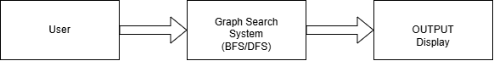
Short explanation:
The Context diagram shows the high-level boundary of the Graph Search System. An external User supplies graph definitions and algorithm parameters, while the system processes the traversal and displays the output results on the screen.

3. Container Diagram (Level 2)
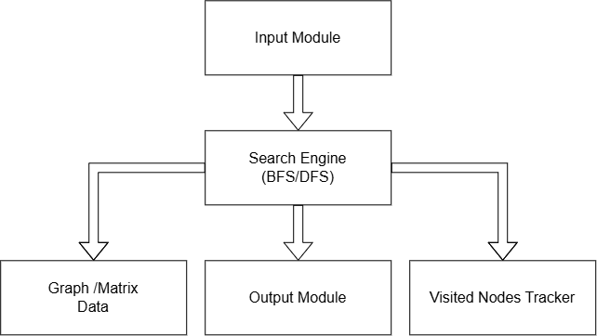

Explanation of each container:
- Input Module:
Validates user input, adjacency matrix definitions, and initial search state parameters.

- Search Engine (BFS/DFS):
Core execution container that processes graph traversal algorithms.

- Graph / Matrix Data:
Holds graph structural data, neighbor lists, and edge weights in memory.

- Visited Nodes Tracker:
Maintains state memory to record explored nodes and prevent infinite loops.

- Output Module:
Formats and prints the final traversed path sequence, depth levels, and node metrics.

4. Component Diagram (Level 3)
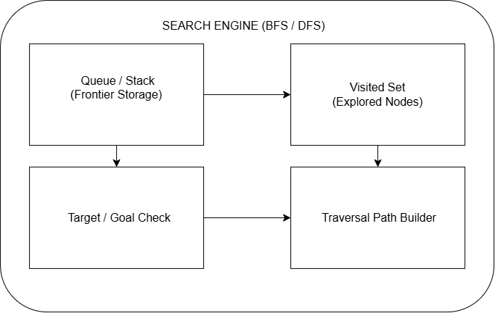

Short explanation of components:
The Search Engine container relies on four internal components: the Queue / Stack component manages frontier node order, the Visited Set tracks processed elements, the Target / Goal Check component verifies stop conditions, and the Traversal Path Builder constructs the final node sequence.

5. Code Level Overview (Level 4)
Main classes / functions:
- class GraphNode: Represents individual nodes with key values, parent pointers, and neighbor lists.
- class GraphSearch: Stores adjacency representations and coordinates traversal execution.
- def bfs_search(graph, start, target): Implements queue-based breadth-first traversal logic.
- def dfs_search(graph, start, target): Implements stack-based depth-first traversal logic.
- def build_path(target_node): Backtracks parent pointers to generate the final path.

6. Design Decisions
Separating the Visited Nodes Tracker from the core queue/stack frontier logic ensures modular state checking with O(1) set lookups, preventing duplicate state expansion and minimizing memory overhead during deep graph traversals.

7. AI Contribution Note
- AI tools used: Gemini
- What AI helped with: Drafting C4 architecture report structure and component explanations.
- What I did myself: Designed all diagrams in draw.io, configured BFS/DFS algorithm components, and finalized report formatting.

8. Conclusion
Designing a full 4-level C4 architecture provided structural clarity on how search algorithms transition from high-level user interactions down to low-level data structure management. This modular separation simplifies future algorithm upgrades and optimization tracking.

